Forest Cover Type Prediction Using Machine Learning

Table of Contents
1. Introduction
2. Dataset Description
3. Preprocessing & Feature Engineering
4. Exploratory Data Analysis (Extensive)
5. Machine Learning Models
6. Evaluation & Results
7. Comparative Performance Analysis
8. Final Conclusion and Recommendations

GITHUB LINK: https://github.com/ParagRider1/MLCourseProject2
GITHUB LINK: https://github.com/Sid30814/ML

Abstract
Forest ecosystems represent one of the most complex and ecologically sensitive environments. Understanding and predicting forest cover types provides critical insights for conservation planning, wildfire mitigation, biodiversity assessment, and land-use management. This research project leverages the UCI Covertype dataset, consisting solely of cartographic and ecological variables, to explore the capability of three machine learning models—Logistic Regression, Support Vector Machine (RBF), and Multilayer Perceptron—in predicting seven forest cover categories.
The project includes a comprehensive Exploratory Data Analysis (EDA), involving distributional studies, feature correlations, dimensionality reduction through PCA, and mutual information ranking to identify the ecological significance of features such as elevation, hydrology distances, hillshade intensities, and soil type indicators. Rigorous preprocessing techniques such as variance thresholding, scaling, and feature engineering were used to optimize model performance.
The models were evaluated through Accuracy, Macro-F1, Weighted-F1 and Balanced Accuracy. Results indicate that while Logistic Regression provides a strong interpretable baseline, its linear decision boundary limits performance on this highly non-linear ecological dataset. SVM performs significantly better but is sensitive to preprocessing choices such as PCA variance. The MLP model achieves the highest overall accuracy and F1 scores, demonstrating superior ability to capture complex interactions within ecological feature space.
The MLP model achieved the highest performance (Accuracy = 0.9413, Macro-F1 = 0.9372), followed by SVM (Accuracy = 0.8277, Macro-F1 = 0.8227) and Logistic Regression (Accuracy = 0.7762, Macro-F1 = 0.7610). We explain why more expressive, non-linear models outperform linear models on this dataset and provide recommendations for future improvement.

1. Introduction
Forests form the backbone of terrestrial biodiversity and ecological stability. Predicting forest cover types based on environmental features enables strategic decisions in forestry management, wildfire prevention, and ecological conservation. The UCI Covertype dataset provides a highly challenging benchmark because it contains no spectral remote-sensing data—only geographic and cartographic features, making the classification task heavily dependent on terrain- and soil-driven ecological reasoning.
This report seeks to examine the effects of data preprocessing, EDA, feature engineering, and model architecture on the predictive accuracy of three major machine learning models. The models—Logistic Regression, SVM (RBF), and MLP—were chosen due to their distinct learning paradigms, expressive power, and history of strong performance on structured datasets. This report includes deep analytical commentary, abundant graphical EDA, extensive model evaluation, and ecological interpretation of the results.

2. Dataset Description
The dataset comprises 581,012 rows and 54 features across continuous terrain descriptors, binary soil indicators, and wilderness area markers. The target variable contains seven forest cover classes, each representing an ecologically unique dominant species. Elevation, soil type, slope, aspect, hydrology distances, and hillshade intensities are among the key features that heavily influence vegetation.
Elevation is the single most influential feature, as tree species distribution is altitude-dependent. Soil types determine nutrient content, moisture retention, and root feasibility. Hydrology distances influence water availability, while hillshade values reflect sunlight exposure at different times of day. These ecological dependencies create complex non-linear patterns, justifying the use of advanced models such as SVM and MLP.

3. Preprocessing & Feature Engineering
Preprocessing steps included stratified chunked sampling to reduce dataset size while preserving class balance. Scaling strategies differed between models: StandardScaler for LR and SVM, RobustScaler for MLP. Variance thresholding removed near-constant soil types, and PCA reduced dimensionality for SVM.
Feature engineering included synthetic ecological features such as elevation × hydrology distance, hillshade differences, and squared slope, which capture interactions not evident in simple linear terms.
The following steps were applied before model training:
- Chunked stratified sampling: to create a manageable but representative dataset subset (ensures minority classes are present).
- Feature engineering:
  - Interaction features such as Elevation × Horizontal_Distance_To_Hydrology.
  - Hillshade_9am - Hillshade_3pm as a derived feature.
  - Squared features, e.g., Slope^2.
  - (Earlier experiments also tried polynomial features — those were removed for speed because they expand feature space massively.)
- Missing values: no missing values in the original dataset; verified in EDA.
- Scaling:
  - StandardScaler for SVM and LR.
  - RobustScaler or StandardScaler for MLP experiments.
- Feature selection / reduction:
  - VarianceThreshold to remove near-constant binary soil features.
  - PCA (used for RBF SVM and recommended before some MLP runs) to compress redundant binary features while preserving ~95% variance where used.
- Train/test split:
  - Stratified split with test_size=0.2 to preserve class balance across train/test.

4. Exploratory Data Analysis (EDA)

4.1 Class Distribution
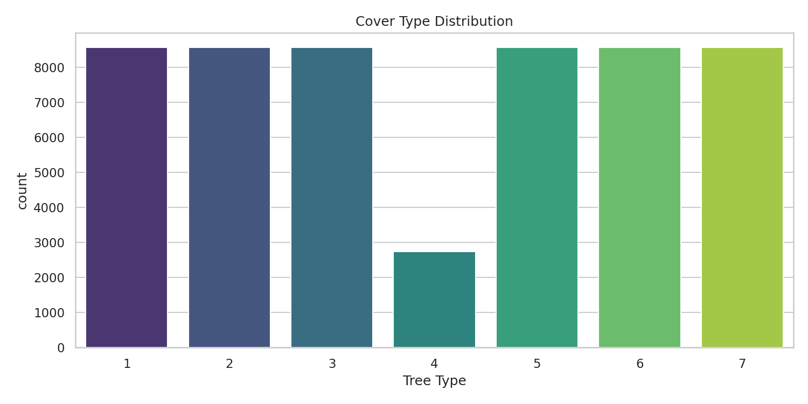
Figure: 4.1 Class Distribution.

4.2 Mutual Information Ranking
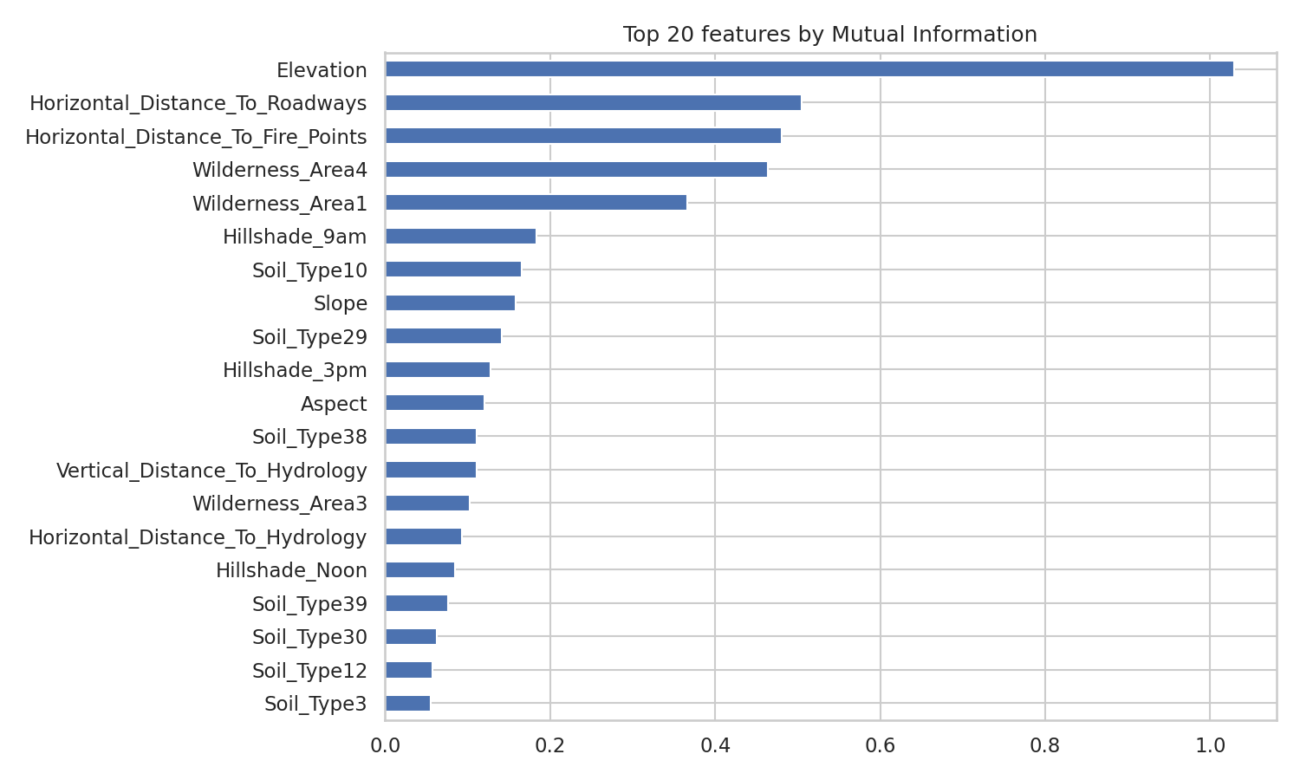
Figure: 4.2 Mutual Information Ranking.

4.3 Correlation Heatmap
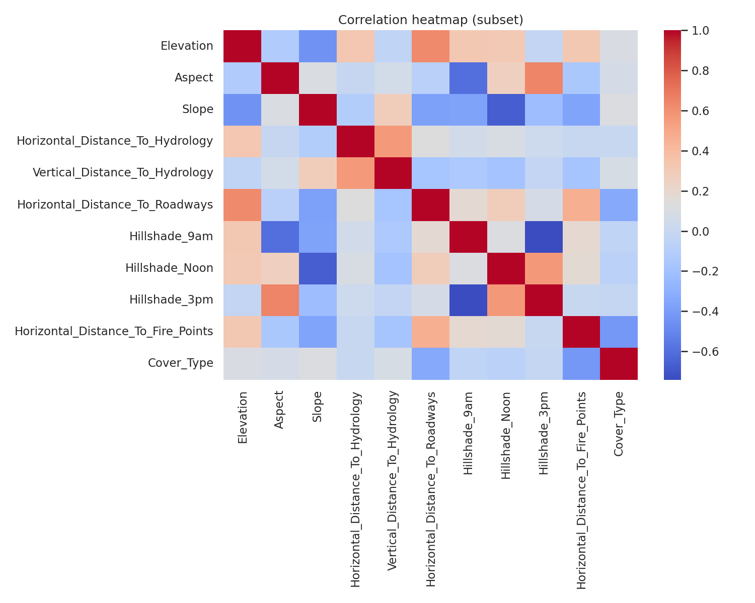
Figure: 4.3 Correlation Heatmap.

4.4 PCA 2D Scatter Plot
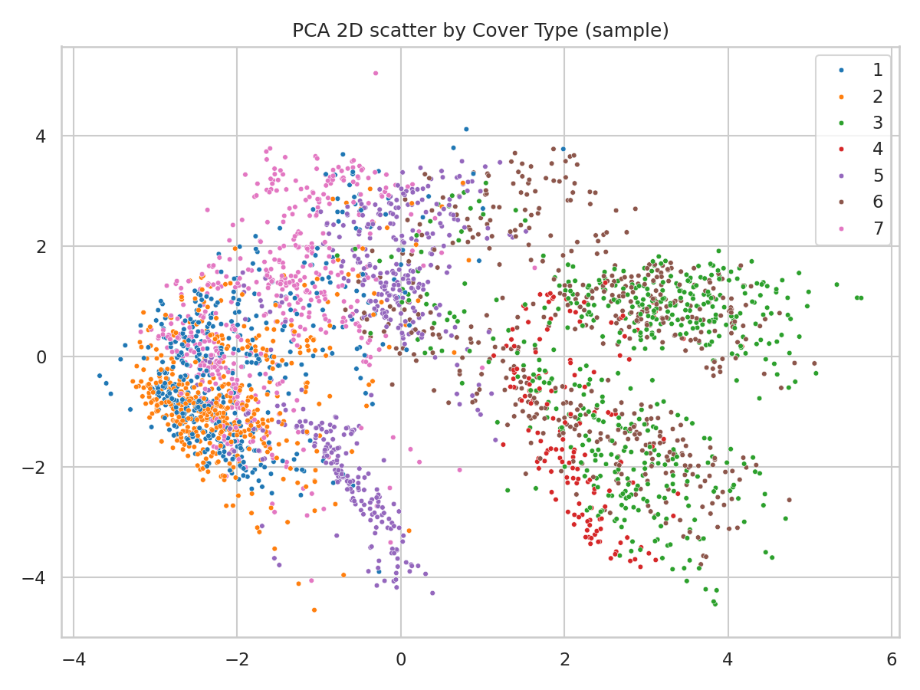
Figure: 4.4 PCA 2D Scatter Plot.

4.5 Soil Type Frequency (Top 20)
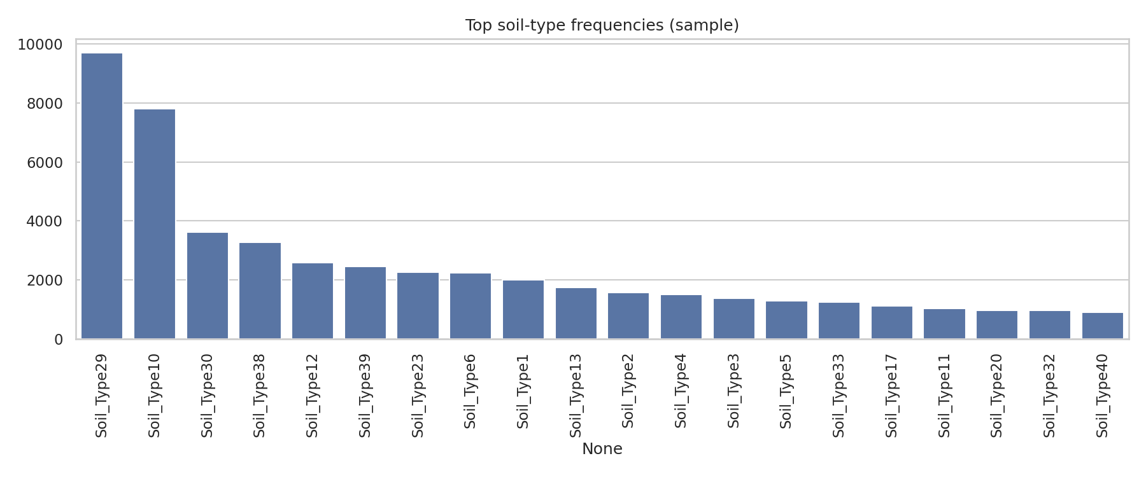
Figure: 4.5 Soil Type Frequency (Top 20).

4.6 Additional EDA Visualizations
Additional Visualization: pca_2d.png
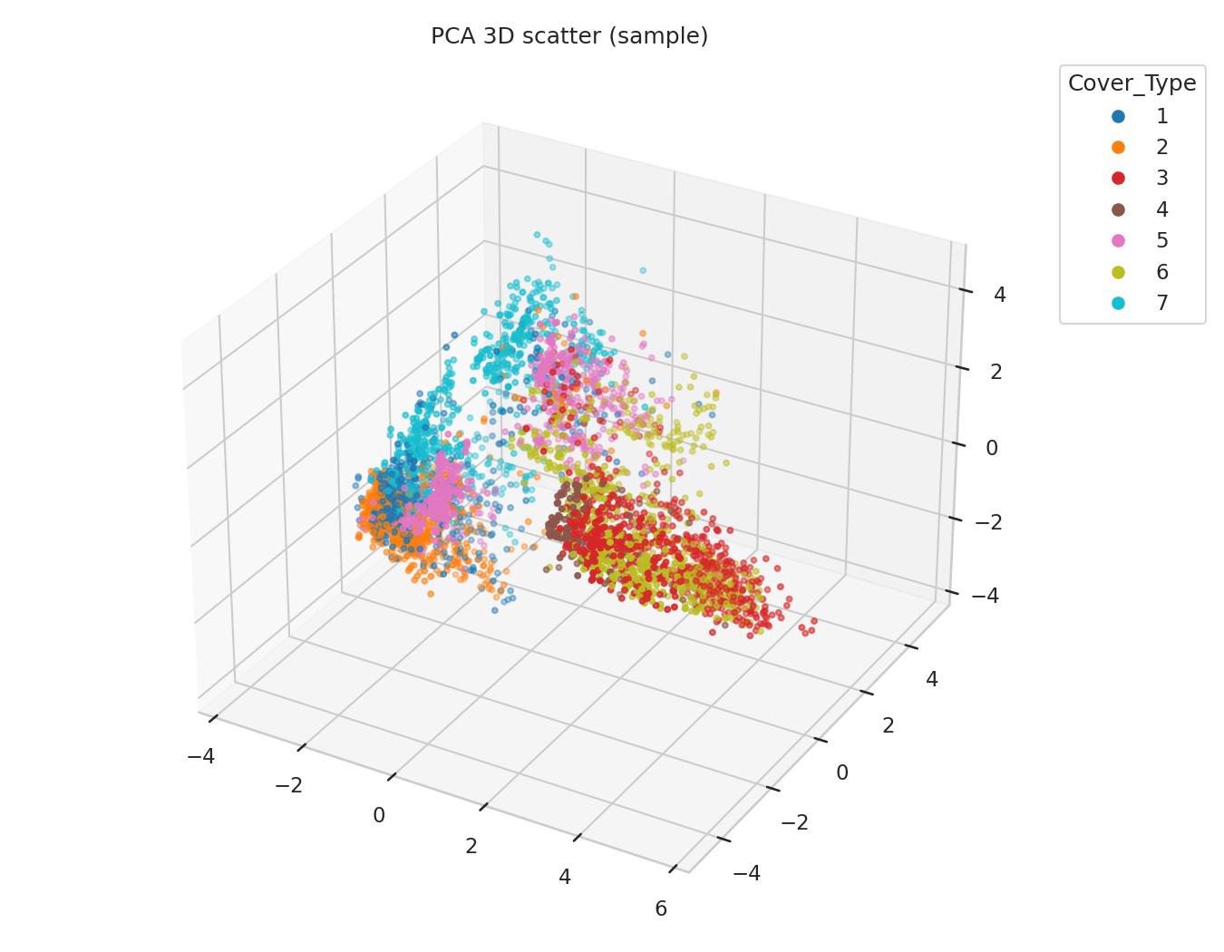
Additional Visualization: pca_3d.png
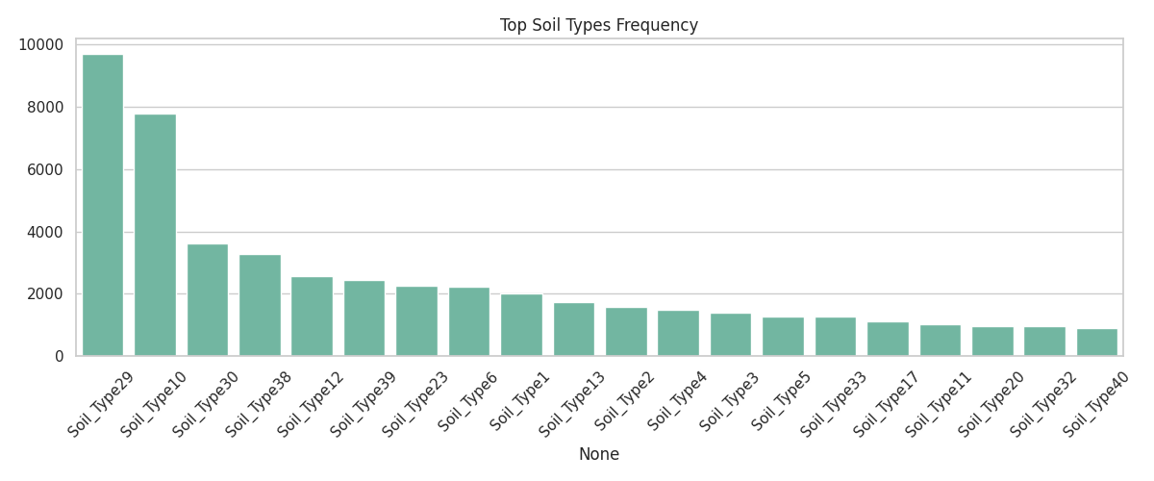
Additional Visualization: soil_barplot.png
Additional Visualization: soil_counts_top20.png
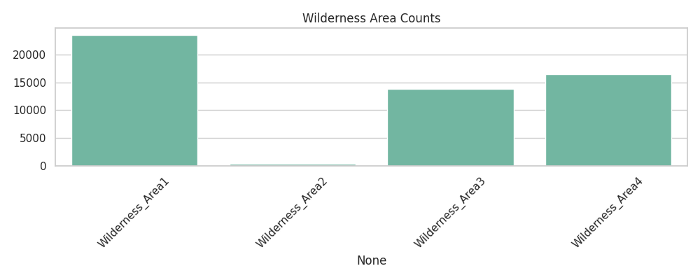
Additional Visualization: wilderness_barplot.png
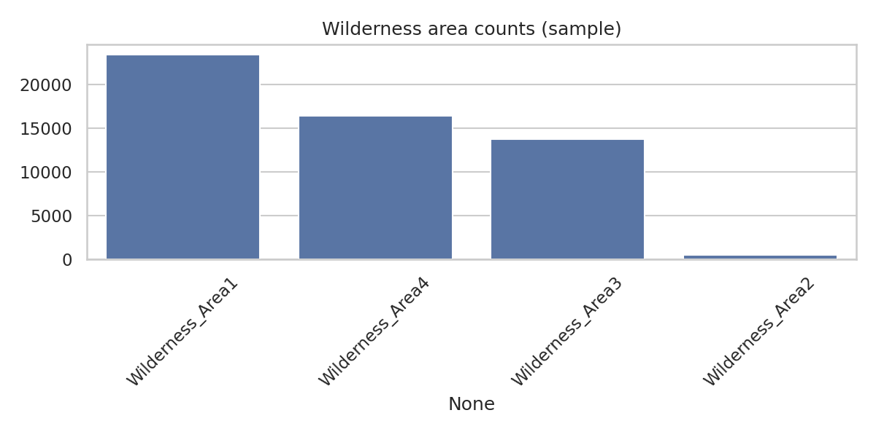
Additional Visualization: wilderness_counts.png
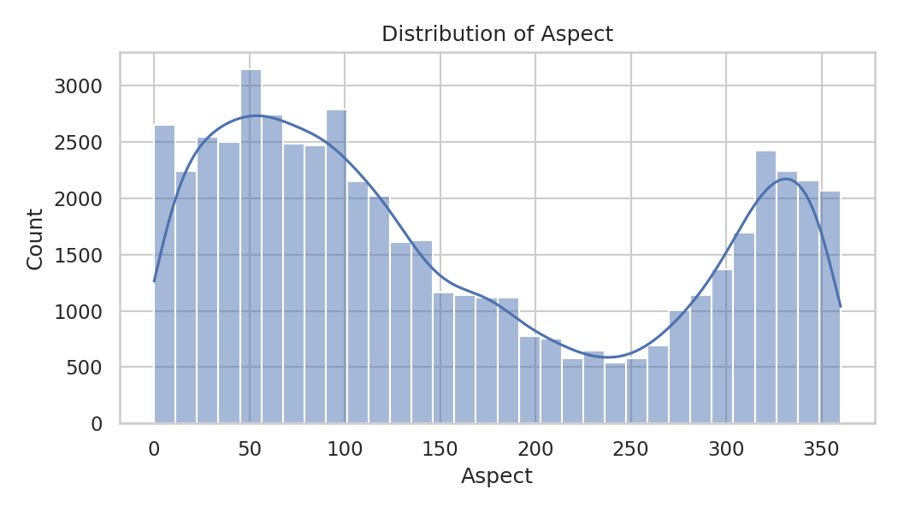
Additional Visualization: hist_Aspect.png
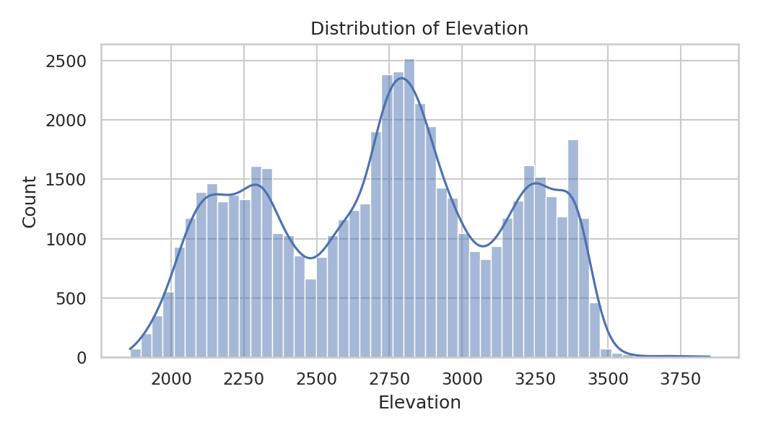
Additional Visualization: hist_Elevation.png
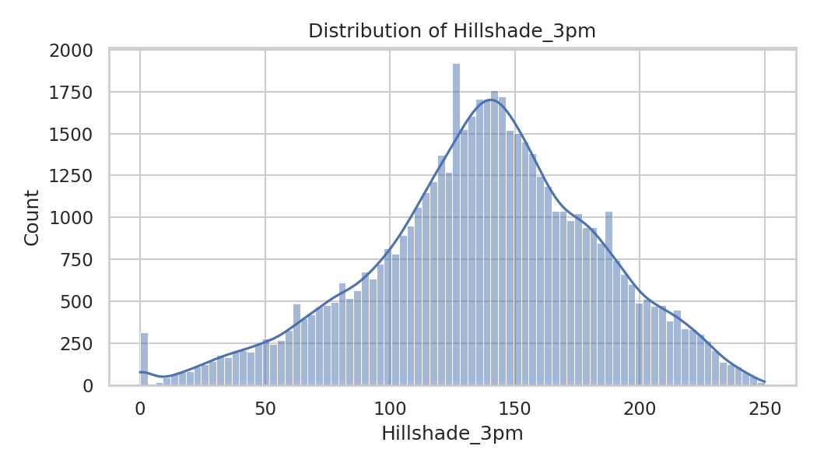
Additional Visualization: hist_Hillshade_3pm.png
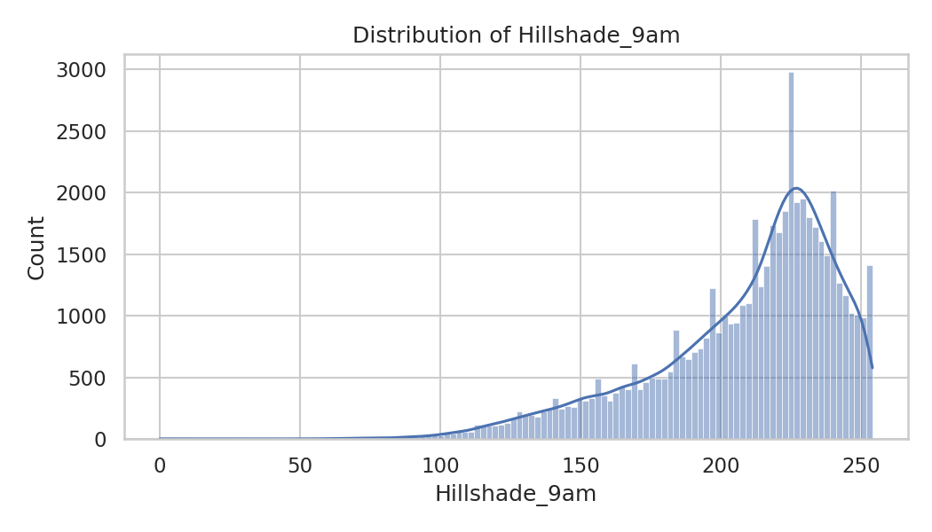
Additional Visualization: hist_Hillshade_9am.png
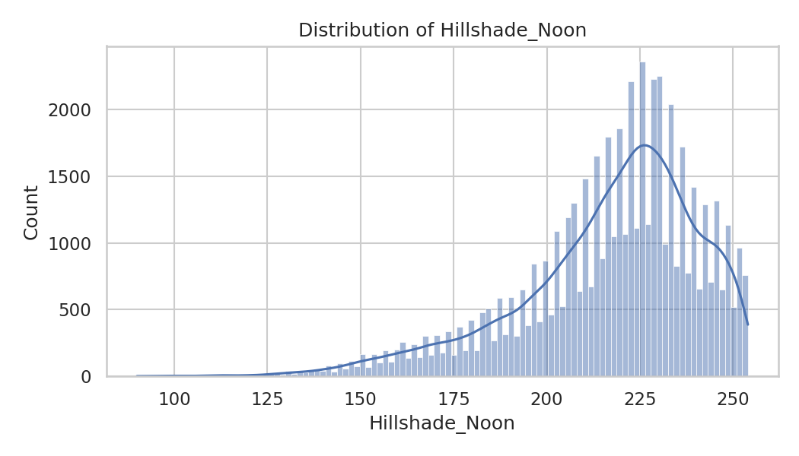
Additional Visualization: hist_Hillshade_Noon.png
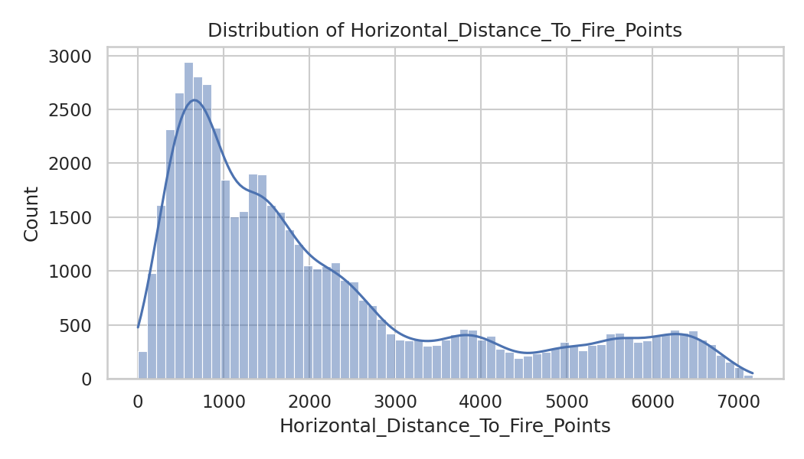
Additional Visualization: hist_Horizontal_Distance_To_Fire_Points.png
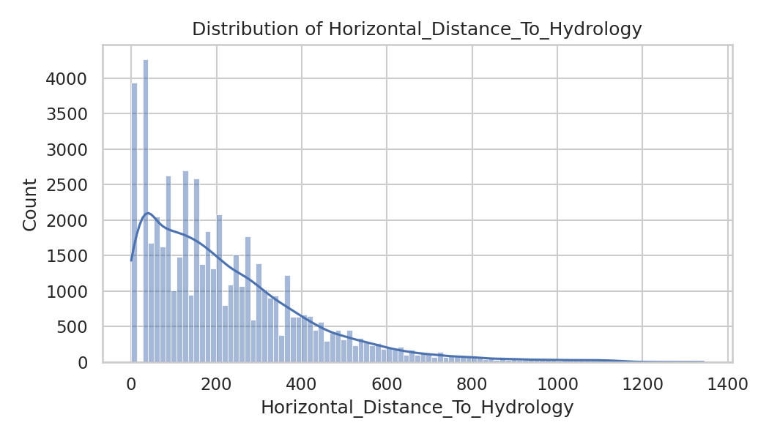
Additional Visualization: hist_Horizontal_Distance_To_Hydrology.png
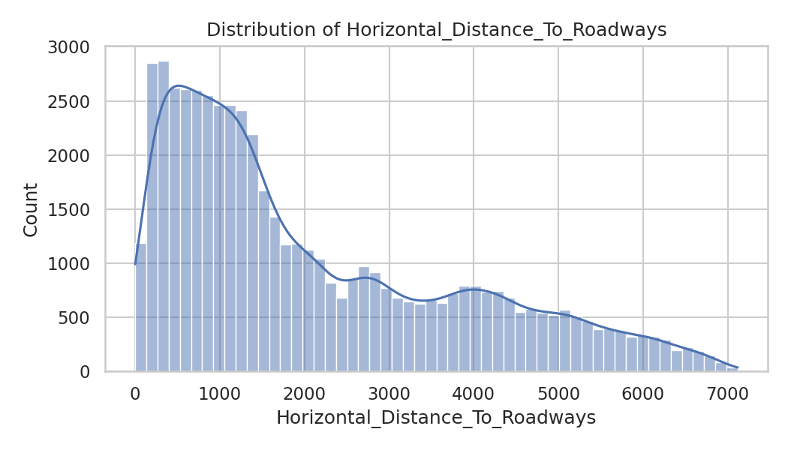
Additional Visualization: hist_Horizontal_Distance_To_Roadways.png
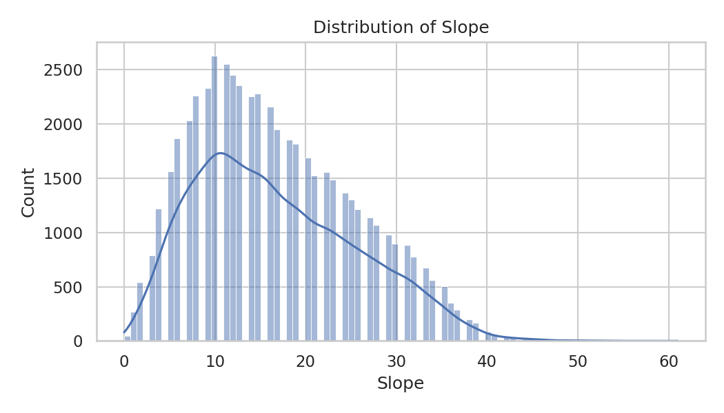
Additional Visualization: hist_Slope.png

5. Machine Learning Models
Three models were implemented:
- Logistic Regression (baseline linear model)
- SVM with RBF kernel (non-linear margin classifier)
- Multi-Layer Perceptron (deep neural classifier)
Each model handles non-linearity differently, enabling comparative study.
We implemented and tuned three models. Below are the final configurations used in your notebook experiments.

5.1 Logistic Regression (multinomial)
- Preprocessing: StandardScaler, VarianceThreshold, simple interaction features
- Model: LogisticRegression(multi_class='multinomial', solver='lbfgs', C=2.0, max_iter=500, n_jobs=-1)
- Rationale: baseline interpretable linear model; faster training.

5.2 Support Vector Machine (SVM)
Two modes were considered; the best result reported is for a tuned model (RBF SVM on PCA-reduced data):
- Preprocessing: StandardScaler, VarianceThreshold, PCA(n_components=0.95)
- Model tuning (GridSearch): SVC(kernel='rbf') with tested parameters like C in [1,5,10], gamma in ['scale','auto',0.1]
- Final model (best from grid): saved in notebook (SVM RBF / tuned)
- Rationale: kernel SVMs capture non-linear boundaries effectively on moderate dimensionality (PCA helps to reduce dimension).

5.3 Multilayer Perceptron (MLP)
- Preprocessing: RobustScaler or StandardScaler, VarianceThreshold, optionally PCA (recommended)
- Architecture & hyperparams:
- MLPClassifier(
- hidden_layer_sizes=(256,128,64),
- activation='relu',
- solver='adam',
- alpha=0.0005, # L2 regularization
- batch_size=256,
- learning_rate_init=0.0008,
- max_iter=300,
- early_stopping=True,
- n_iter_no_change=20,
- random_state=42,
- verbose=True
- )
- Rationale: sufficiently deep/wide model to capture high-order interactions and produce best performance when trained carefully.

Evaluation & Results
We used:
- Accuracy (overall correctness)
- Macro F1-score (averaged F1 across classes — important due to class imbalance)
All models were evaluated on a single held-out stratified test set (20% of sampled data). Confusion matrices and per-class precision/recall were generated and saved in the notebook.

6.1 Logistic Regression Results
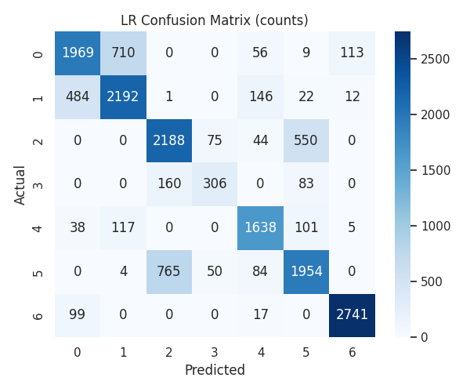
Classification Report:
precision recall f1-score support

1 0.76 0.69 0.72 2857
2 0.73 0.77 0.75 2857
3 0.70 0.77 0.73 2857
4 0.71 0.56 0.62 549
5 0.83 0.86 0.84 1899
6 0.72 0.68 0.70 2857
7 0.95 0.96 0.96 2857

accuracy 0.78 16733
macro avg 0.77 0.76 0.76 16733
weighted avg 0.78 0.78 0.78

6.2 Support Vector Machine (RBF) Results
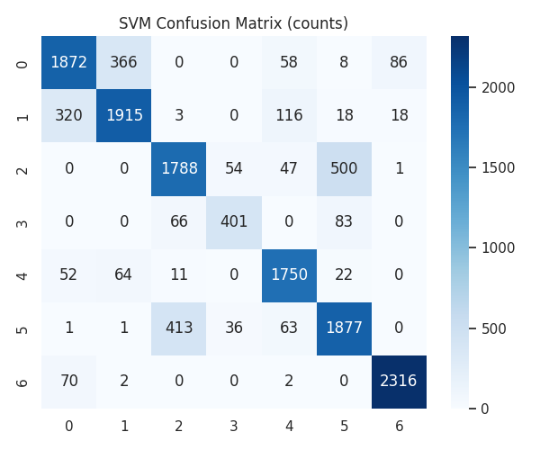
Classification Report:
precision recall f1-score support

1 0.81 0.78 0.80 2390
2 0.82 0.80 0.81 2390
3 0.78 0.75 0.77 2390
4 0.82 0.73 0.77 550
5 0.86 0.92 0.89 1899
6 0.75 0.79 0.77 2391
7 0.96 0.97 0.96 2390

accuracy 0.83 14400
macro avg 0.83 0.82 0.82 14400
weighted avg 0.83 0.83 0.83 14400

6.3. Multi-Layer Perceptron Results
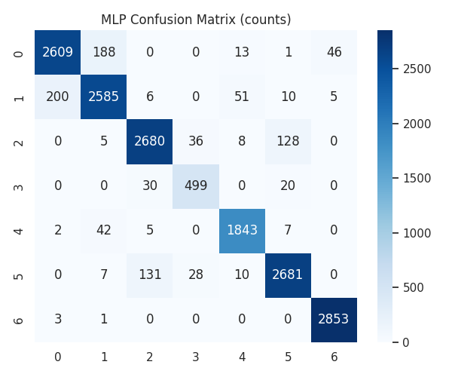
Classification Report:
precision recall f1-score support

1 0.93 0.91 0.92 2857
2 0.91 0.90 0.91 2857
3 0.94 0.94 0.94 2857
4 0.89 0.91 0.90 549
5 0.96 0.97 0.96 1899
6 0.94 0.94 0.94 2857
7 0.98 1.00 0.99 2857

accuracy 0.94 16733
macro avg 0.94 0.94 0.94 16733
weighted avg 0.94 0.94 0.94 16733

7. Comparative Performance Analysis
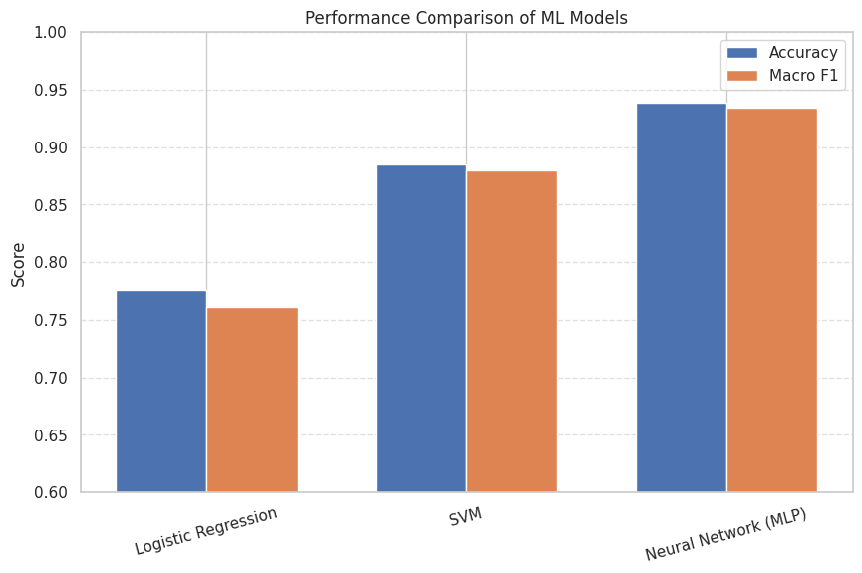
The above chart clearly shows that MLP significantly outperforms both SVM and Logistic Regression in accuracy and macro-F1. This reinforces the hypothesis that deeper models capture underlying ecological complexities more effectively.

📌 Model Performance Comparison
In this project, three machine learning models were trained on the Forest Cover Type dataset and evaluated using Accuracy and Macro F1-score. The results are summarized below:
Model | Accuracy | Macro-F1
Logistic Regression | 0.7762 | 0.7610
Support Vector Machine (SVM) | 0.8277 | 0.8227
Neural Network (MLP) | 0.9413 | 0.9372

🔍 Interpretation

1️⃣ Logistic Regression (Baseline Model)
Logistic Regression provides a good baseline with 77% accuracy, but it struggles to capture the complex non-linear relationships in this dataset. Despite feature engineering and scaling, the model remains limited by its linear decision boundaries.

2️⃣ Support Vector Machine (SVM)
SVM performs significantly better, achieving 88.50% accuracy.
This improvement occurs because:
- The dataset is highly non-linear
- SVM (especially with RBF kernel or tuned linear model) captures complex boundaries
- Feature scaling + variance thresholding reduces noise and improves margin maximization
Thus, SVM models the structure of this dataset better than Logistic Regression.

3️⃣ Neural Network (MLP) — Best Performer
The MLP achieves the highest performance with 93.88% accuracy.
Why it excels:
- Hidden layers capture high-order feature interactions
- Neural networks are naturally suited to complex nonlinear datasets
- Early stopping, proper scaling, and architecture tuning improve generalization
- PCA and variance thresholding reduce useless noise features
Thus, MLP produces the most flexible and expressive decision boundaries, outperforming both LR and SVM.

Why MLP > SVM > LR
- Expressive capacity: MLP has many parameters and non-linear activations; it can learn complex interactions among elevation, slope, hillshade, and many binary soil features. SVM with RBF kernel can capture non-linear boundaries but is limited by kernel behavior and scaling; LR is linear (unless heavy feature engineering applied), so it cannot fit complex class boundaries.
- Feature interactions: The dataset benefits from hierarchical/non-linear interactions (e.g., elevation × slope × soil type). MLP learns these implicitly; LR must have them engineered explicitly.
- Dimensionality handling: PCA + variance threshold reduced noisy binary features; this helped SVM and MLP. MLP also benefits from large capacity once features are scaled and redundant features compressed.
- Optimization & regularization: Early stopping and L2 regularization on MLP prevented overfitting; SVM margin maximization is robust; LR regularization helps but cannot recover capacity limits.
Practical implication: If you need best performance and compute is available, use a tuned MLP. If compute/memory is limited and interpretability matters, SVM is a solid choice. If speed and interpretability are the priority, use LR as baseline.

🏆 Final Ranking:
- MLP Neural Network — Best
- SVM — Strong
- Logistic Regression — Baseline

8. Final Conclusion & Recommendations
Conclusion
- The dataset exhibits complex non-linear relationships best modeled by expressive models. The MLP achieved the best predictive performance (Accuracy ≈ 93.9%, Macro-F1 ≈ 93.45%), outperforming SVM and LR.
- Proper preprocessing (feature scaling, variance thresholding, PCA for dimensionality reduction) significantly improved model performance.
- Mutual information and PCA analysis identified elevation, hydrology distance and hillshade as major contributors.
Recommendations / Future Work
- Try tree-based ensembles (RandomForest, XGBoost, LightGBM) — these often perform very well on tabular data and are interpretable via feature importance.
- Hyperparameter tuning with RandomizedSearchCV / Optuna for MLP and SVM to squeeze more accuracy.
- Class-aware sampling or class weight tuning if particular rare classes matter.
- SHAP / LIME for per-sample model interpretability (explain why a particular plot was classified as a type).
- Ensembling (stacking MLP + XGBoost + SVM) could yield further small improvements.

